Video | Link | QR Code
Russia | https://video.link/w/YJ1jc | 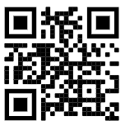
Philippines | https://video.link/w/NN1jc | 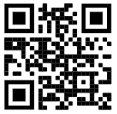
South Africa | https://video.link/w/KP1jc | 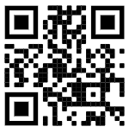
Mexico | https://video.link/w/cR1jc | 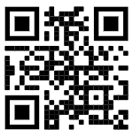
Japan | https://video.link/w/SV1jc | 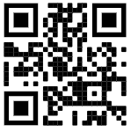
Korea | https://video.link/w/BY1jc | 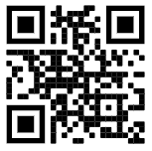
India | https://video.link/w/wa2jc | 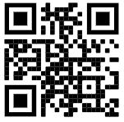
Argentina | https://video.link/w/ed2jc | 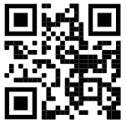
China | https://video.link/w/cf2jc | 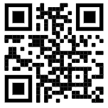
Vietnam | https://video.link/w/Xf2jc | 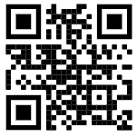
Ireland | https://video.link/w/gm2jc | 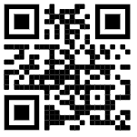
Scotland | https://video.link/w/Mo2jc | 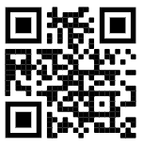
Brazil | https://video.link/w/Js2jc | 